***+ANUDIP FOUNDATION***

A Project Report on

**FOOD DELIVERY MANAGEMENT SYSTEM**

By

Batch: ANP-D0453

Student ID: AF0477133

Name: Gouri Madral

**Under the Guidance of**

Mrs. Rajshri Chandrabhan Thete

FOOD DELIVERY MANAGEMENT SYSTEM

A Food Delivery Management System (FDMS) is a software solution designed to streamline the food delivery process for restaurants, food establishments, and delivery services. The system aims to improve efficiency, reduce costs, and enhance customer satisfaction.

**Entities:**

* Admin
* Customer
* Food
* Orders
* Payment
* Delivery Boy
* Category

**ATTRIBUTES OF ENTITIES:**

1. **Admin**

* Attributes:
* AdminID (primary key)
* Name
* Email_ID
* Contact_No
* Password

1. **Customer**

* Attributes:
* CustomerID (primary key)
* Name
* Email_ID
* Contact_No

1. **Food**

* Attributes:
* FoodID (primary key)
* Price
* Name
* Description
* Quantity

1. **Orders**

* Attributes:
* OrderID (primary key)
* OrderDate
* Time
* OrderStatus

1. **Payment**

* Attributes:
* PaymentID (primary key)
* Date
* PaymentMethod

1. **Delivery Boy**

* Attributes:
* DeliveryBoy_ID (primary key)
* Name
* Contact_No

1. **Category**

* Attributes:
* Veg
* Non-Veg

**ENTITY RELATIONSHIP DIAGRAM - RESTAURANT MANAGEMENT SYSTEM**

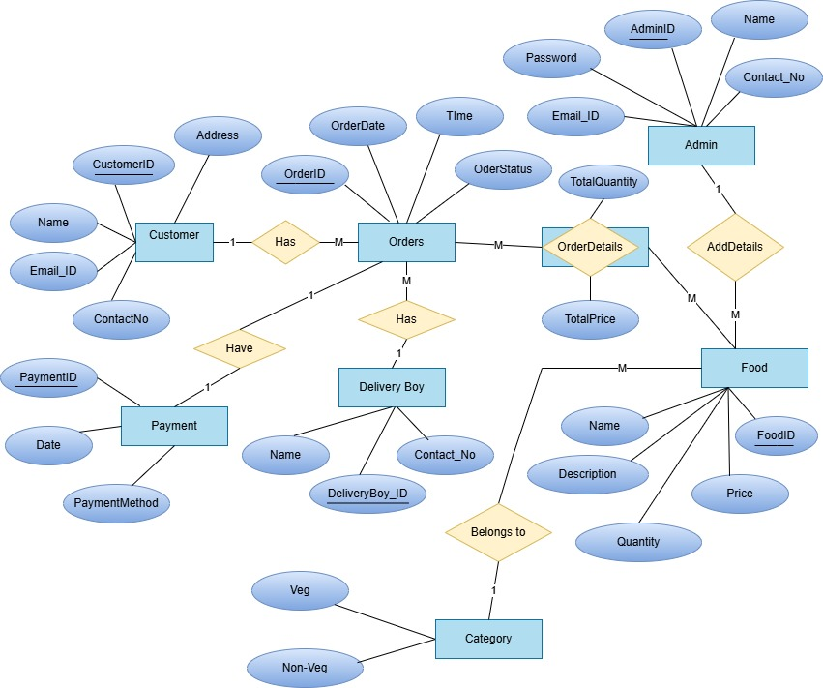

**CONCLUSION:**

In summary, the implementation of a Food Delivery Management System can have a transformative impact on the food delivery industry. By leveraging its features and benefits, businesses can enhance customer experiences, increase efficiency, and drive growth. As the food delivery market continues to evolve, the adoption of FDMS will become increasingly essential for businesses seeking to remain competitive and thrive in this dynamic landscape. A Food Delivery Management System is a crucial tool for food establishments and delivery services seeking to improve operational efficiency, customer satisfaction, and revenue growth. By streamlining order management, delivery logistics, and customer interactions, FDMS enables businesses to stay competitive in the rapidly evolving food delivery market.

**DATABASE CREATION QUERY:**

**Query OK, 1 row affected (0.01 sec)**

**mysql> CREATE TABLE Admin (**

**-> admin_id INT PRIMARY KEY,**

**-> admin_name VARCHAR(255),**

**-> admin_Phone VARCHAR(20),**

**-> admin_Email VARCHAR(255)**

**-> );**

**mysql> CREATE TABLE Staff (**

**-> staff_id INT PRIMARY KEY,**

**-> staff_name VARCHAR(255),**

**-> staff_rating INT,**

**-> staff_Email VARCHAR(255)**

**-> );**

**Query OK, 0 rows affected (0.02 sec)**

**mysql> CREATE TABLE Items (**

**-> item_id INT PRIMARY KEY,**

**-> category VARCHAR(255),**

**-> price DECIMAL(10, 2),**

**-> Name VARCHAR(255),**

**-> Order_count INT**

**-> );**

**Query OK, 0 rows affected (0.01 sec)**

**mysql>**

**mysql> CREATE TABLE Customers (**

**-> customer_id INT PRIMARY KEY,**

**-> customer_name VARCHAR(255),**

**-> customer_Phone VARCHAR(20),**

**-> customer_email VARCHAR(255),**

**-> customer_password VARCHAR(255)**

**-> );**

**Query OK, 0 rows affected (0.01 sec)**

**mysql> CREATE TABLE Parcel (**

**-> Parcel_id INT PRIMARY KEY,**

**-> item_id INT,**

**-> customer_id INT,**

**-> amount DECIMAL(10, 2),**

**-> order_id INT,**

**-> Time TIMESTAMP,**

**-> FOREIGN KEY (item_id) REFERENCES Items(item_id),**

**-> FOREIGN KEY (customer_id) REFERENCES Customers(customer_id)**

**-> );**

**Query OK, 0 rows affected (0.02 sec)**

**mysql> CREATE TABLE Orders(**

**-> order_id INT PRIMARY KEY,**

**-> time TIMESTAMP,**

**-> amount DECIMAL(10, 2),**

**-> customer_id INT,**

**-> FOREIGN KEY (customer_id) REFERENCES Customers(customer_id)**

**-> );**

**Query OK, 0 rows affected (0.04 sec)**

**mysql> CREATE TABLE Tables (**

**-> Table_number INT PRIMARY KEY,**

**-> Total_people INT,**

**-> Time TIMESTAMP,**

**-> customer_id INT,**

**-> item_id INT,**

**-> order_id INT,**

**-> FOREIGN KEY (customer_id) REFERENCES Customers(customer_id),**

**-> FOREIGN KEY (item_id) REFERENCES Items(item_id),**

**-> FOREIGN KEY (order_id) REFERENCES Orders(order_id)**

**-> );**

**Query OK, 0 rows affected (0.04 sec)**

**mysql> CREATE TABLE feedback(feedback_id INT NOT NULL PRIMARY KEY,**

**-> Staff_rating INT,**

**-> customer_id INT,**

**-> staff_id INT,**

**-> item_rating VARCHAR(255),**

**-> FOREIGN KEY (customer_id) REFERENCES customers(customer_id),**

**-> FOREIGN KEY (staff_id) REFERENCES staff(staff_id)**

**-> );**

**Query OK, 0 rows affected (0.05 sec)**

**mysql> CREATE TABLE payment (**

**-> payment_id INT PRIMARY KEY AUTO_INCREMENT,**

**-> payment_type VARCHAR(50) NOT NULL,**

**-> amount DECIMAL(10, 2) NOT NULL,**

**-> customer_id INT,**

**-> FOREIGN KEY (customer_id) REFERENCES customers(customer_id)**

**-> );**

**Query OK, 0 rows affected (0.05 sec)**

**mysql> show tables;**

**+----------------------------------------+**

**| Tables_in_restaurant_management_system |**

**+----------------------------------------+**

**| admin |**

**| customers |**

**| feedback |**

**| items |**

**| orders |**

**| parcel |**

**| payment |**

**| staff |**

**| tables |**

**+----------------------------------------+**

**9 rows in set (0.00 sec)**